# Grid Based Simulation Methods

## Sequential Conditional Simulation Methods

Sequential conditional simulation methods are kriging based methods, in which unsampled locations are sequentially visited in a random order until all the unsampled points are visited. At each unsampled locations, a value of the desired variable is simulated, based on the estimate, as well as the local uncertainty. Multiple realizations are possible through the random order in which the unsampled locations are visited, as well as the way in which a value is sampled at the unsampled location.

Two most commonly used methods for sequential simulation of both discrete & continuous variables are:

1. Sequential Indicator Simulation (SIS)
2. Sequential Gaussian Simulation (SGS)

The simulation can be done for a single variable as well as for multiple variables (called **cosimulation** similar to cokriging).

The transforms usually used are:

1. Indicator transform
2. Gaussian transform
3. Probability transform

### Single Variable Simulation

It is working with a single variable e.g. porosity or facies and no secondary variable (then cosimulation).

The application of this method involves **5 steps**:

1. Transforming the original data into a new domain
2. Modelling variograms in the transformed domain
3. Determining the randomly selected path to visit all the unsampled locations (different paths produces different realizations)
4. Sequentially estimating values at the unsampled locations with kriging based techniques
5. Back-transforming the values to the original domain

#### Step 1: Transformation into a New Domain

This step involves transforms the original data into a new domain e.g. indicator, Gaussian etc.

##### Indicator Transform

Indicator transform for a continuous variable:

Indicator transform for a discrete variable:

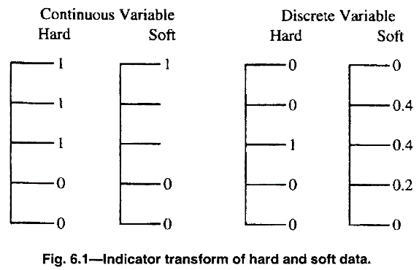

The method is used for both *hard data* (known with certainty) as well as *soft data* (incomplete information). For a discrete variable, an indicator value of 1 indicates 100% certainty of presence and 0 indicates 100% certainty of absence. A value of 0 and 1, indicates the degree of certainty of presence of that discrete data.

##### Gaussian Transform (continuous data)

The Gaussian transform happens as per the ranking of both discrete and continuous data.

A sample from **continuous dataset** that is ranked among the samples has a CDF value:

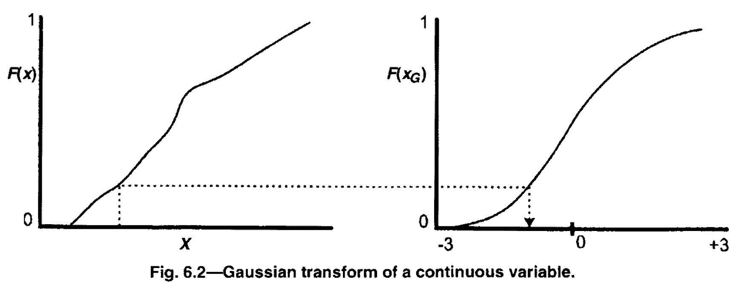

##### Gaussian Transform (discrete data): Truncated Gaussian Transformation

When Gaussian transformation is done on a **discrete dataset**:

In the example, the order A, B, C and D is important and has to be kept unchanged while back transforming.

We define the min-max in the Gaussian space, and we don’t allow the values in the transformed domain to be less than -3 and more than +3. Accordingly for each facies/category the corresponding values in the Gaussian space is determined. E.g. *Category A*: -3 to -1.2, *Category B*: -1.2 to 0, *Category C*: 0 to 1, *Category D*: 1 to 3.

With the given limits, we randomly assign any value in the Gaussian space to represent a particular category and this type of random assignment can create random neighbourhood values. This randomness can be avoided by using correlated numbers.

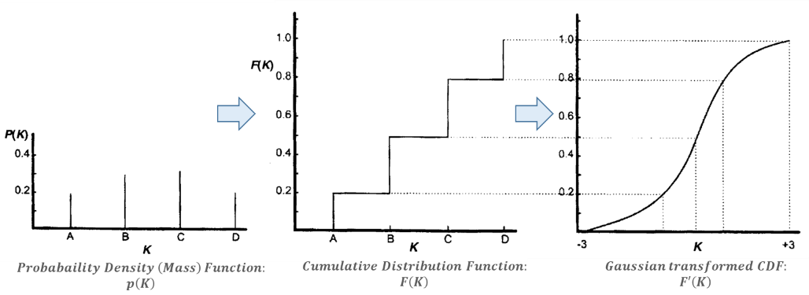

##### Probability Transform

It is simpler than the indicator and the Gaussian transform. For a **continuous variable**, once the CDF is created, we use the CDF as the transform variable with value between 0 and 1. For **discrete variables**, once a CDF is constructed, a value is randomly sampled within the limits and assigned. E.g. in the above example for category A, a random value between 0 and 0.2 is assigned, for category B, a random value between 0.2 and 0.5 is assigned etc.

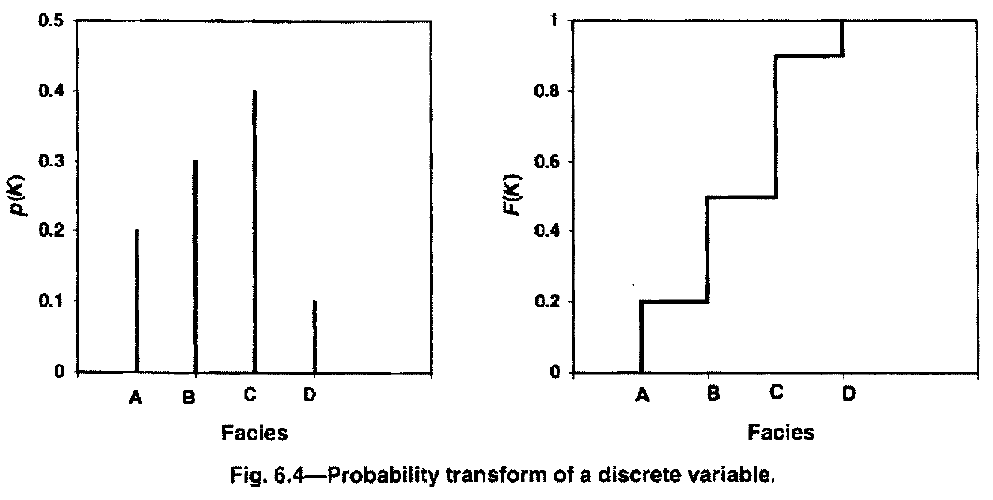

Few salient points about all the three main types of transforms above:

1. Indicator transform is the most flexible of all, as it can incorporate both hard as well as soft data. However, it loses the information when a continuous data is transformed into indicator data. Once transformed back, even though we know the class interval we can’t have the precise value.
2. Both Gaussian and probability transform although doesn’t have any loss of information, however can’t accommodate the incorporation of the soft data. Also artificial randomness can be introduced when transforming a discrete dataset.

#### Step 2: Spatial modelling in a transformed domain

The variogram is estimated in the transformed domain and modelled with an appropriate relationship. Sometimes, different thresholds can exhibit different spatial relationship, as compared to just one for a Gaussian/probability transformed dataset. On the other hand, Gaussian/probability transform just provide the simplicity.

##### Indicator transformed data

Number of variograms are equal to the number of thresholds to be modelled. For discrete variables, number of threshold values equal to the number of categories (no. of facies). For continuous variables, the number depends on the number of sample points.

##### Gaussian/probability transformed data

Only one variogram to be modelled as compared to several for indicator transform.

#### Step 3: Random Path Selection

It involves selection of a path, in which every unsampled location is visited. With the help of a random number generator, a sequence of random numbers corresponding to the total number of gridblocks is generated, and based on the order, a path is selected in which the unsampled locations are visited.

#### Step 4: Estimation at the Unsampled Location

*Conventional kriging* only selects the original sample points within the search neighbourhood. However, *conditional simulation techniques* select the original samples as well as the prior simulated values. (The search neighbourhood for the unsampled location is randomly selected from last step.) This has two consequences:

1. Selecting a previously simulated values, spatial relationship amongst the simulated values are explicitly honoured, which is not possible in conventional kriging technique.
2. Selection of prior simulated values makes the estimation at the unsampled locations dependent on the order in which unsampled locations are visited.

The number of prior simulated values within a search neighbourhood can be limited so as have a fair balance between the original sampled data and the simulated values.

##### Indicator transformed data:

Ordinary kriging, continuous data:

Ordinary kriging, discrete data:

For continuous variable, we obtain a CDF and for discrete data (e.g. facies) we obtain a local PDF (of the accessed location).

***Local uncertainty:*** (non-parametric method) For continuous variable, each of the thresholds has a reasonable (non-decreasing) probability associated with them. For discrete variables, probabilities associated to each of the discrete data quantifies the probabilities.

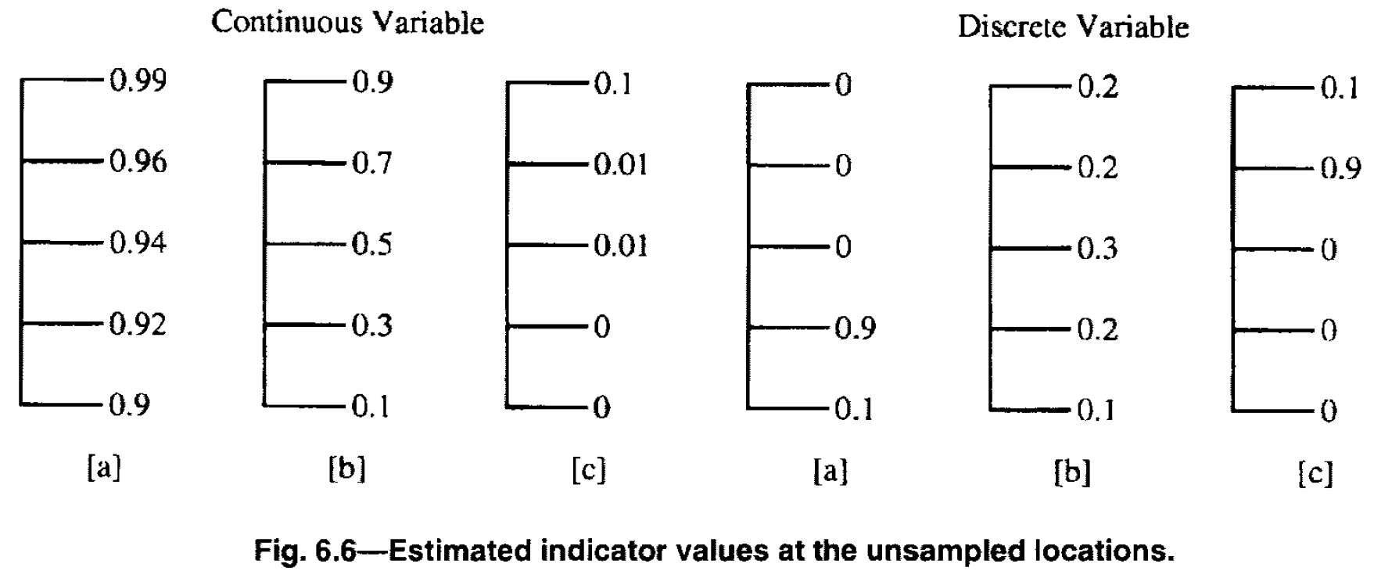

##### Gaussian transformed data:

It requires only one estimate at the unsampled location.

Ordinary Kriging, continuous variable:

Ordinary Kriging, discrete variable:

**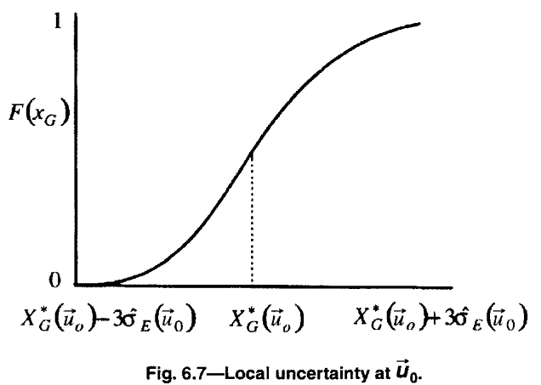*Local uncertainty:*** In addition to estimating the value at the unsampled location, the error variance is also estimated. And if we know the estimate and the associated error variance for a Gaussian distribution, we capture the local uncertainty. The CDF for a such a local variable is defined as below, where 99% of values occur between and .

##### Probability transformed data

The value is estimated similar to Gaussian transform.

***Local uncertainty:*** (non-parametric method) The procedure for estimating the local uncertainty is not well established. One possibility is to use kriging weights to assign the local uncertainty. Since, in an Ordinary Kriging all the weights add up to 1, we can use the weights assigned to each sample within the search neighbourhood as the probability mass function. (So our estimated value is going to be closer to the sample with the highest weight and accordingly other samples)

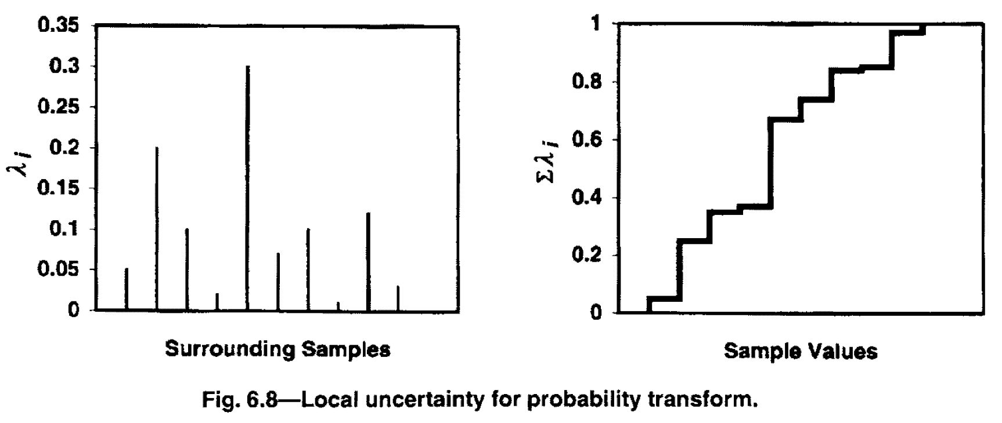

#### Step 5: Back Transform

##### Indicator Transformed Data

3 steps: (i) Correction of data (ii) Sampling from Random Number Generator (iii) Transformation

###### Correction in the data:

For **continuous variable**, the posterior distribution represents the cumulative distribution function, one critical requirement is that it must be a non-decreasing function, starting from the lowest threshold. Because each of the thresholds are estimated independently and it may happen that the non-decreasing might not be satisfied. So we do the following operation. (Fig. 6.9)

For a **discrete variable**, the correction needs to be if the sum doesn’t add up to 1. So the values are simply normalized.

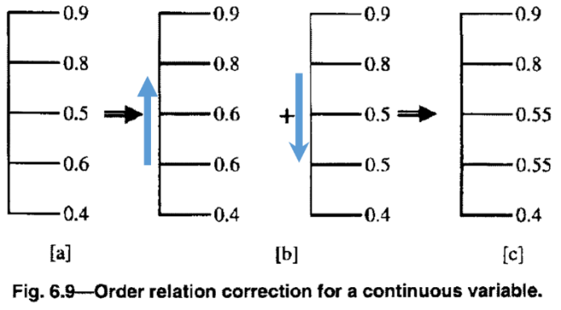 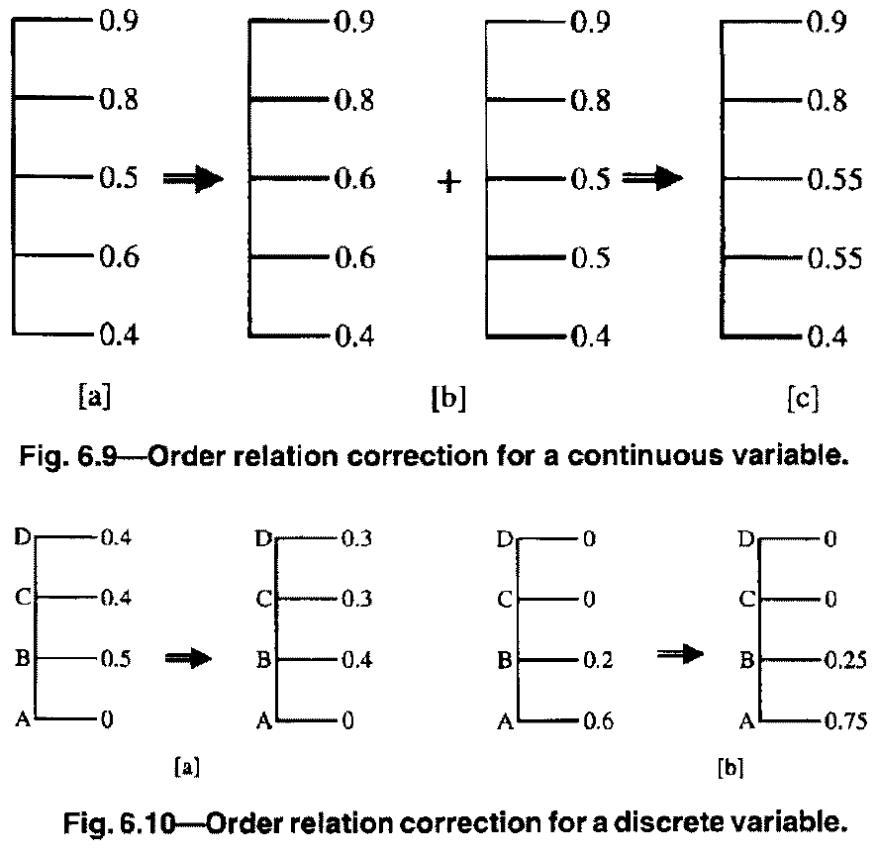

The corrections are completely random in both discrete as well as continuous cases. But in most cases, the corrections are very small, hence acceptable.

###### Transformation

For a **continuous variable**, once the order relation correction is made, a realization can be sampled from the posterior distribution. A random number is selected using random number generator and depending on the value an appropriate class is selected. (See Fig. 6.11) Also the values are interpolated between the thresholds to assign a value at the unsampled location.

E.g. with a random number generator, even if we get the same value (say 0.5) at all the 3 locations Location A, B & C, we will get the following interpolated values of porosity 7.57%, 8.33% & 2.5% at Location A, B & C respectively.

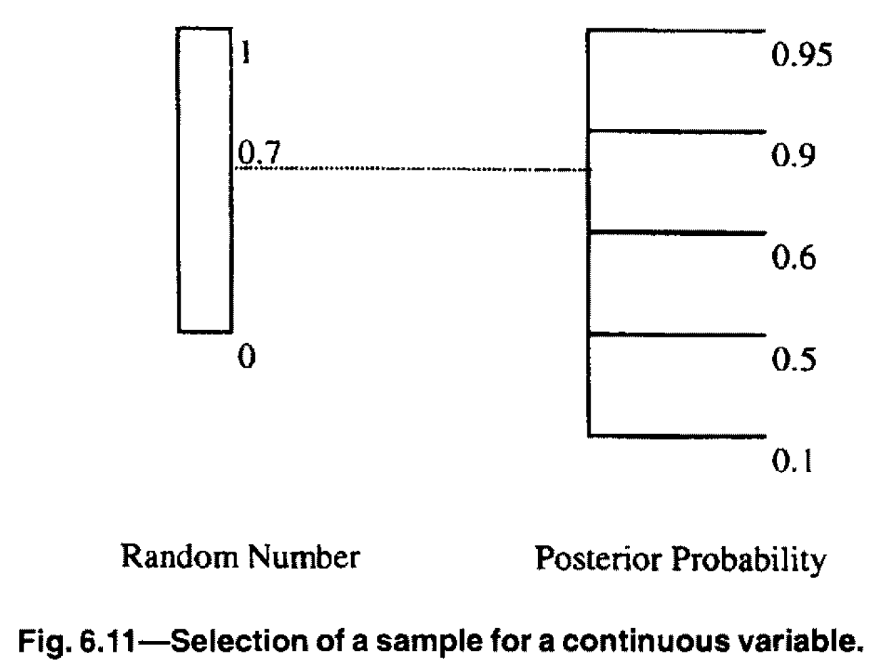 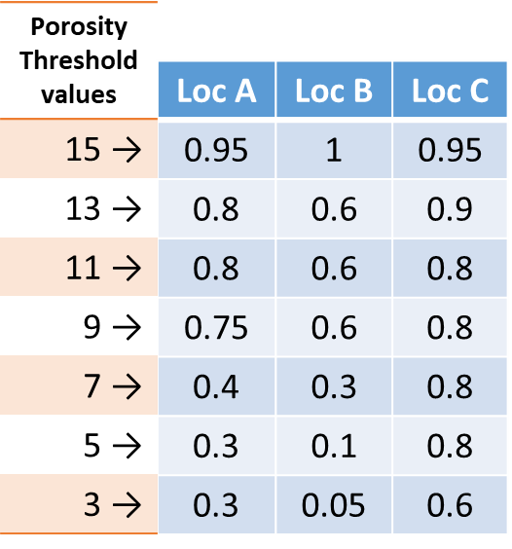

For a **discrete variable**, we first generate a CDF from the PDF (Fig 6.12) and follow the same approach as in the continuous variable, except values in between the thresholds are assigned the threshold values from above.

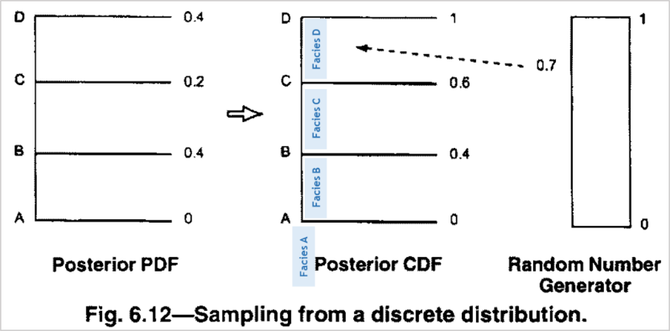

The process continues until all the data are back-transformed to the original domain.

##### Gaussian Transformed Data

For a Gaussian transformed variable we estimate the value and the associated error variance (thus calculating a PDF/CDF), which determines the uncertainty in the estimation. The process for back-transforming a continuous and discrete (truncated Gaussian variable) variable are the same.

Steps: (i) Sampling of data (ii) Back Transformation

###### Sampling of the data

As shown below, a number is randomly sampled (using uniform random number generator) and a value from the Gaussian distribution is picked and the corresponding value from the CDF is read, in the example **Fig. 6.13** below. And it is one of the several realizations that can be generated. 99% of all the probable value lies between .

From the figure alongside, it shows there is a 40% probability that the random number generator (RNG) is going to pick a value between the indicated intervals. However, the final value has a smaller range in the one with smaller standard deviation and wider range in the larger standard deviation. This is to display that, *although a number is picked from a RNG, the values with higher PDF value are going to have a higher probability of occurrence.*

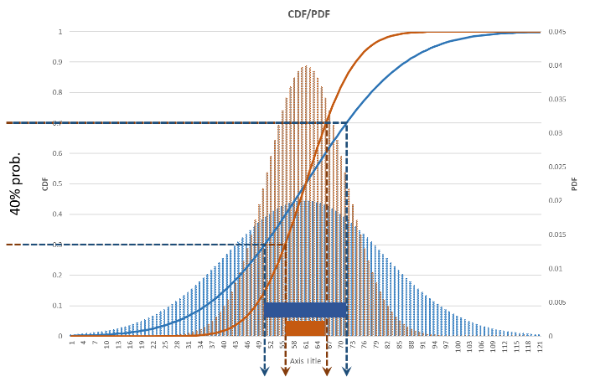

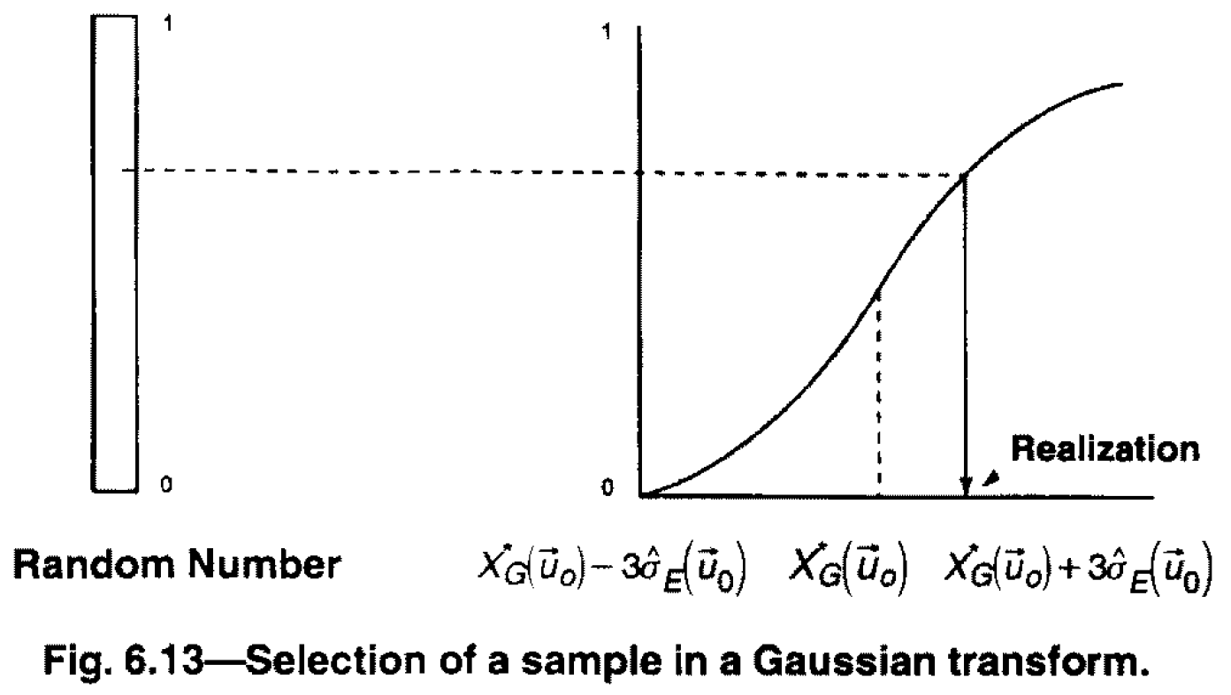

###### Back-transformation

Once the value is sampled, for a **continuous variable** it is just the reverse of the forward transformation (see **Fig. 6.14** above), which is a value is plotted in the Gaussian space and for the same value of CDF, a back transferred value is obtained.

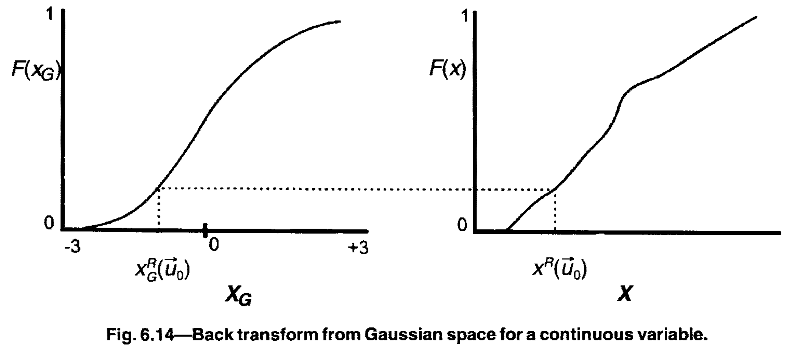

For **discrete variable**, the transformation is done in 2 ways:

*Method 1:* It is a simple reverse of the forward transformation, as show in Fig. 6.15.



*Method 2:* In situation as below illustrated in Fig, 6.16 there are chances that while sampling, the order of facies A+B occurring above C+D is not retained. In that case, defined proportions of individual facies are used to transform the data. (In the example from Fig. 6.17, A:B is 60:40. Again at the lower interval it changes to a C:D proportion.) The method of forcing the back transform to certain prior defined proportions is used extensively for geologically consistent relations. The changing proportions of facies with depth is called **VPCs** or Vertical Proportion Curve.

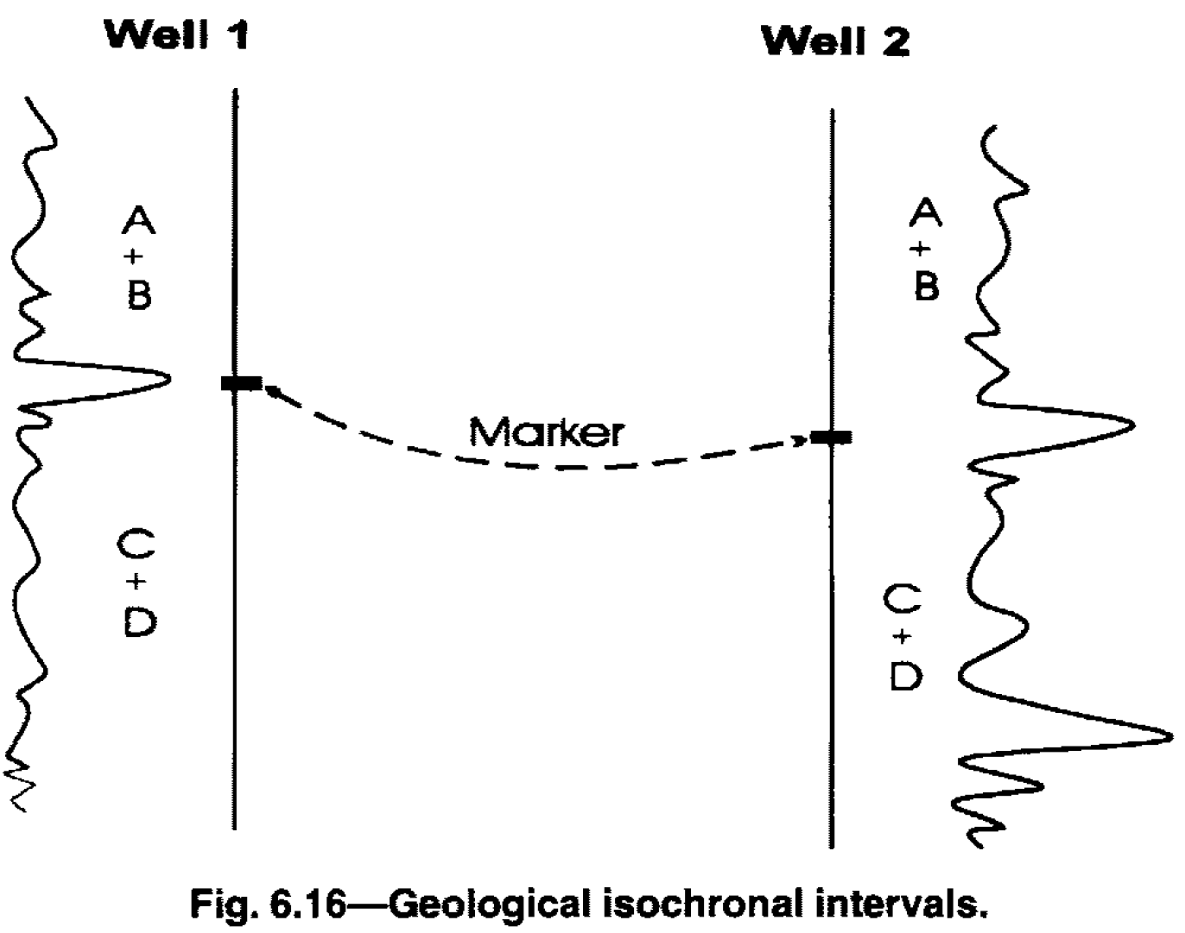 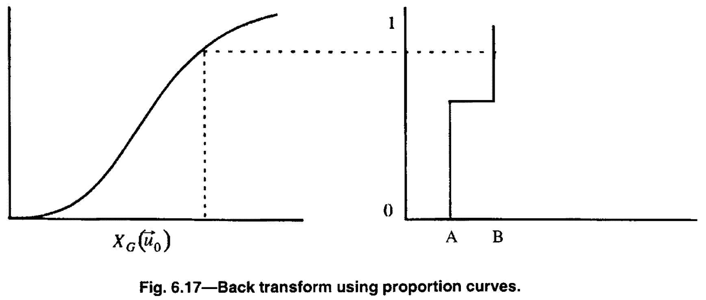

##### Probability Transform

In the Probability transform sampling a value from probability transform is similar for both continuous as well as discrete variables. The PDF is provided by the kriging weights of the nearby samples, therefore we can sample a value using uniform random number generator. (And hence the CDF is generated by adding the kriging weights starting with the smallest transformed sampled value). Once is determined (**Fig. 6.18**), the back transform to the original domain is straightforward for continuous as well as discrete variables as shown in the Figures below.

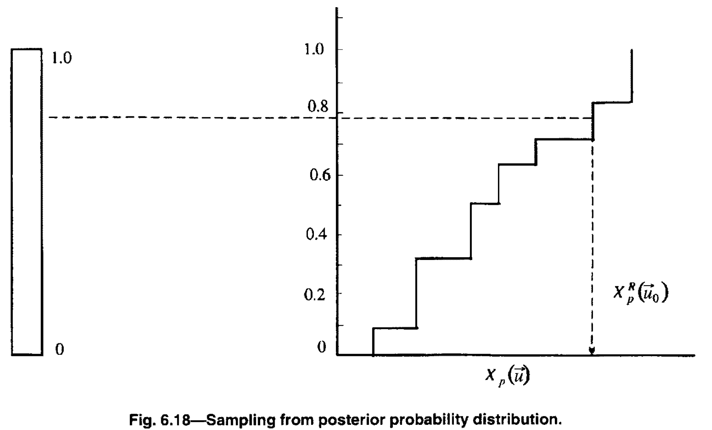 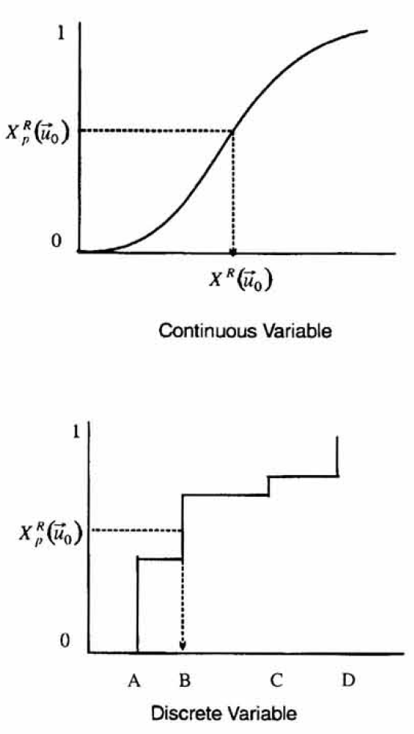 

For facies, indicator transform is most appropriate. For porosity and permeability, Gaussian & Probability transform are most appropriate. However, where the vertical proportion of the geological facies are very important, a Gaussian transform may be more appropriate (TGS) and if different classes of continuous variable different spatial relationships, an indicator transform of the continuous facies is appropriate.

#### Combination of methods

Some advocate the combination of the two methods:

1. Not indicator simulation, but Indicator Kriging + Sequential Gaussian Simulation:

Indicator kriging defines the proportion curves; SGS (or probability transform) for sampling of those curves to assign geological facies. This way spatial relations of geological facies are honoured and smoothness from continuous variable transform (Gaussian or Probability) is also preserved.

1. In sequential simulation, every time a new unsampled location is estimated it is transformed to the original domain, i.e. Step 4 & 5 are carried out simultaneously. This method appears to create a smoother distribution.

#### Field Example: Sequential Gaussian Simulation

#### Field Example: Sequential Indicator Simulation for continuous variable

#### Field Example: Sequential Indicator Simulation for discrete variable

### Sequential Cosimulation

It results in the simulation of multiple attributes simultaneously and is a logical extension of the sequential simulation process. The main advantage of this method is to honour the local relationships between attributes.

E.g. when we independently assign facies and porosity at the gridblocks, it is possible to locally assign inconsistent values, unless a constraint imposing a strict relationship is incorporated.

Once the order of the attributes to simulate is determined, that order is followed at every unsampled location, to ensure the inter-relationship among the various attributes is honoured. E.g. as the relationship shown below.

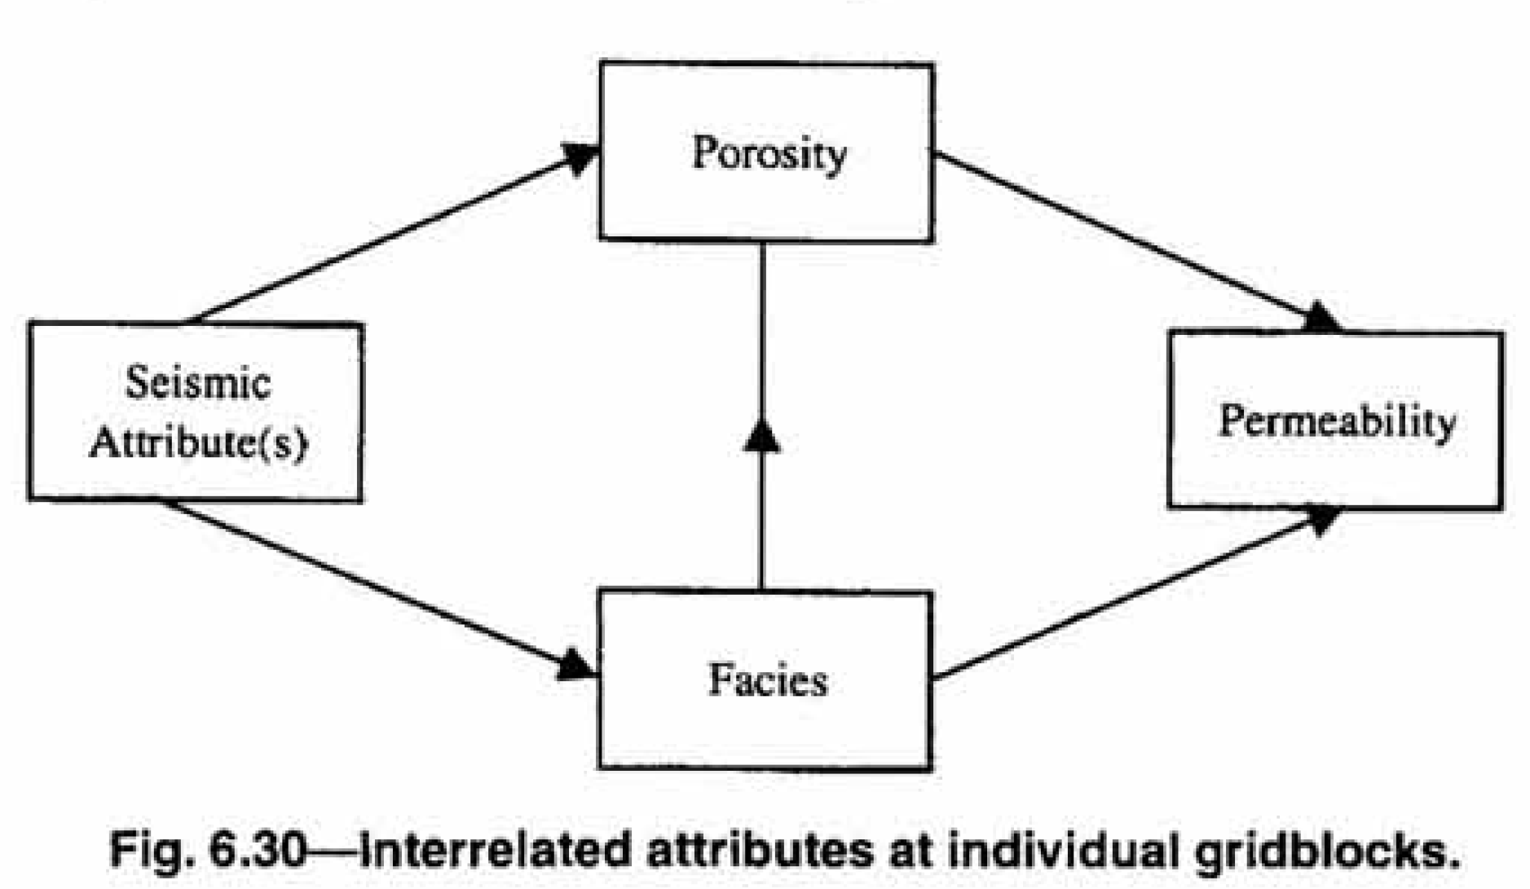

#### Transformation into a new domain

Similar to sequential simulation, the data is transformed into an appropriate domain. For example, facies are transformed to indicator values and the porosity and permeability are transformed to Gaussian variables. To apply the cokriging principles, the relationship between attributes has to be linear.

#### Estimation and modelling variograms

In the transformed domain, variograms of all the variables are estimated. Cross-variograms are required to be modelled between all the pairs of attributes. E.g. if porosity is assumed to be related to seismic data as well as facies, we need cross-variograms between porosity and facies and porosity and seismic data. Cross-variograms are necessary only if the cosimulation is based on the cokriging procedure. If the relationships are not linear, even in the transformed domain, alternate procedures for honouring the relationships are available.

#### Selection of a random path

A random path is selected like in the sequential simulation, which simulates the value based on the original samples as well as prior simulated values.

#### Simulation of Attributes

Unlike sequential simulation, the estimation and sampling is one single step.

It is usually the following:

1. The *value* of the variable is estimated along with the *uncertainty*.
2. Based on value and uncertainty, a value is *sampled* in the transformed domain.
3. The value is back transformed to the original domain.

Also when an unsampled location is visited, all the unknown attributes are visited in the sequential order to preserve their relationship, typically from least dependent to most dependent. E.g. we simulate geological facies first, followed by porosity and then permeability.

The procedure subsequent variables are sampled based on prior values depends on the type of local relationship honoured. Below are several possibilities.

1. Sequential Gaussian Simulation
2. Bayes Rule Cosimulation
3. Proportion Curves Cosimlation

#### Sequential Gaussian Cosimulation

If the transformed domain is a Gaussian space and the relationships among various attributes to be linear, by estimating the values and the error variance, we can quantify the uncertainties.

If **cokriging procedure** is adopted. It uses variograms for primary variable & covariables and the cross-variograms between primary and the covariables.

For **collocated cokriging**, is restricted to only. It only requires the variogram of the primary variables, as the cross-variograms are derived from the primary variogram.

**Salient points for the Sequential Gaussian Cosimulation**:

1. Local uncertainty is captured by the Gaussian distribution
2. Relationship among various variables are linear.
3. SGC is based on mathematically rigorous basis, but might not work for discrete variables.

#### Bayes Rule Cosimulation

This procedure defines a relationship between posterior probability and prior probability.

OR

Where Posterior Probability : Prior probability

For a sample comprising of mutually exclusive events

If can be geological facies and a seismic attribute. So, if we know or probability of seismic attribute for each geological facies as well as probability of occurrence of each geological facies, we can estimate the probability of occurrence of any geological facies, given the particular seismic attribute. See the example below for more clarity:

**Example:** We know the following about an unsampled location:

Probability of the predicting the seismic attribute, when facies are known

Indicator probabilities of each facies (Soft, discrete data)

Solving the posterior probability from the prior probability .

Since the sum has to be 1, then the value has to be divided by . When each is divided by 0.52, we get . So,

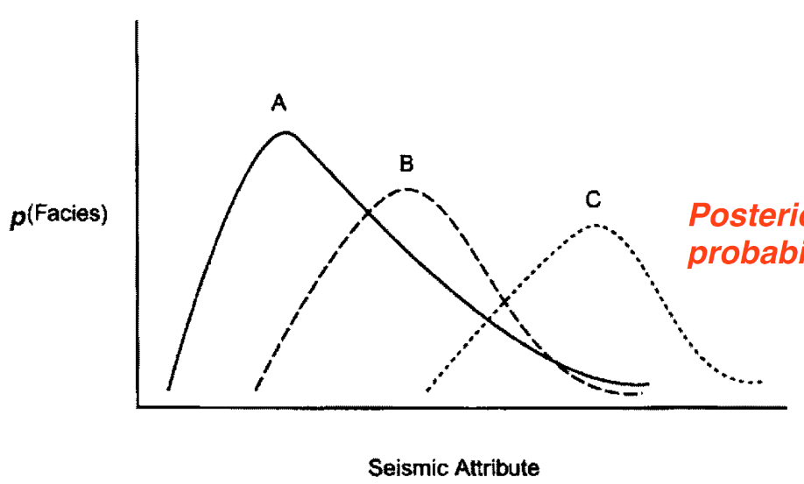This means we improve our prediction of Facies 2 with the knowledge of Seismic data. Facies 1 approaches 0 and Facies 3 is already 0 at the unsampled location.

Seismic data or any secondary data has to be consistent with the subsequent information to reduce the uncertainty.

**Example:** Primary data and secondary data can be porosity and seismic data.

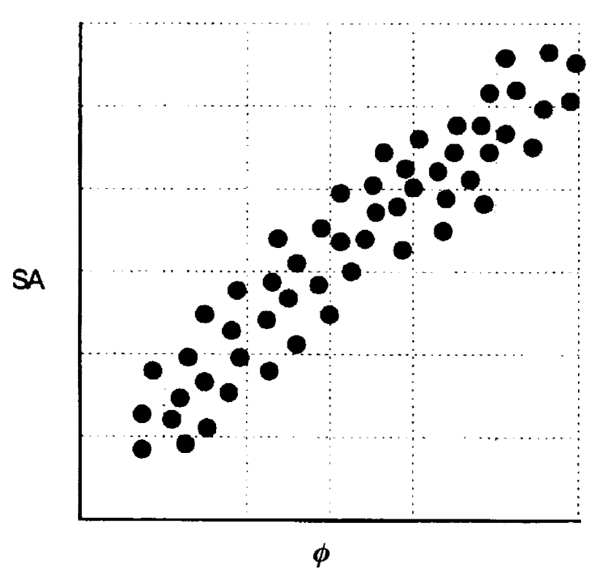The relationship between seismic and porosity is clearly not linear. However, when the data is divided into several classes, we develop value of , which represents the value of he given seismic attribute class, given a porosity class in the *Gaussian domain*. If porosity is estimated using SGS, we can estimate the value and corresponding error variance, and thus the value will fall within a certain class interval, .

With the and we can obtain the posterior distribution with the equation,

. Again adding all the posterior probabilities to 1, we obtain the posterior probabilities of individual porosity classes. This posterior distribution can sample the porosity from the probability classes.

The Bayesian Rule Cosimulation is not only restricted to prior measurements at unsampled locations and also used for prior estimated values e.g. to estimate the permeability values we can use the already estimated porosity values.

**Example:** Updating permeability using data from porosity and facies.

.

: Probability of class l of permeability, based on Gaussian distribution

: Probability of porosity class for a given class of permeability . (Subscript N represents a Normal or Gaussian distribution.) This porosity permeability relationship is obtained for a given geological facies.

**Salient points about the Bayesian rule cosimulation:**

1. It helps to update the prior probability to posterior probability using new information.
2. It is efficient and doesn’t require spatial knowledge from the cross-variograms.
3. It is also applicable to non-linear relationships.
4. Thus it is simple to implement and is based on sound probabilistic principle. However, impletion can be difficult if two types of data provide contrary information. E.g. probabilities for 3 facies are 0.2, 0.8 and 0 and seismic attribute provide conditional probability of those three facies as 0, 0 and 1; then we might not get an answer.

#### Proportion Curves Cosimulation

It is a method similar to ‘proportion curves’ as in SGS for discrete variables or the TGS. The same procedure is used to sample a particular attribute.

Steps for proportion curves simulation. If we have to simultaneously assign the facies and porosity at an unsampled grid location

1. We first assign the facies to the location
2. In next step we must assign porosity to the location based on the estimated value and the associated uncertainty in the Gaussian domain. (up to this it is similar to the SGS)
3. When we want to back transform, we sample a value in the Gaussian domain and we restrict this back transform to porosity value that only corresponds to the particular facies already assigned to the particular location. As shown below, porosity distribution of the facies A only is shown in the CDF. This ensures that the porosity values are consistent with the underlying facies/geology.

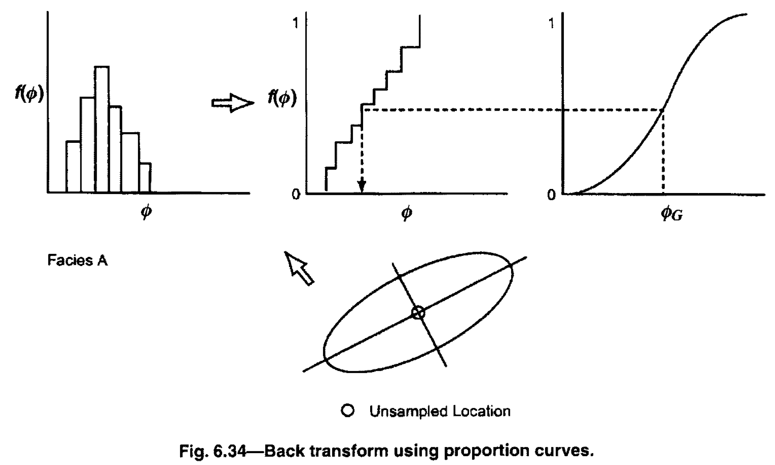

Method to sample permeability with porosity:

1. Permeability is estimated with Gaussian transform and a value is sampled.
2. The back transform is restricted to the conditional distribution of the permeability for a given porosity class.

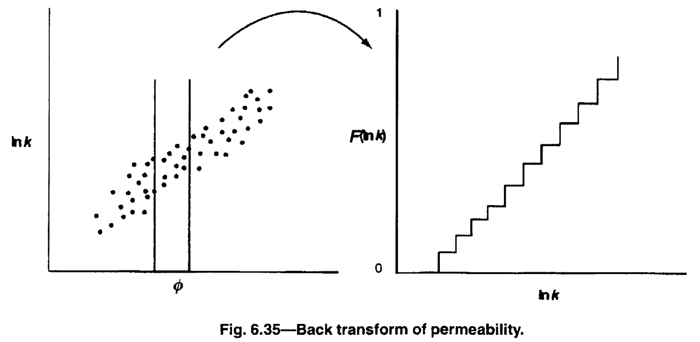

Salient points for the Proportion curves cosimulation:

1. It has the advantage of not requiring a linear relationship between the variables.
2. It also doesn’t require us to model the cross variogram.
3. By restricting the back transform, to only a certain distribution, it always ensure that the conditional distributions of the various attributes are always honoured.
4. It is most robust of the three types of the cosimulation methods discussed here. It strictly honours the distributions of the observed data, and by doing so it could restrict the uncertainty domain much more that the other two methods.

#### Field Example: Sequential Gaussian Cosimulation

## Probability Field Simulation

#### Probability Field Simulation

One disadvantage of sequential simulation process is the fact that once the posterior distribution are constructed, we must use a uniform random number generator to sample a value from that distribution. And for two locations, where estimated values and the posterior distributions are very similar, it is possible that simulated values will be different. (See below Fig 6.42)

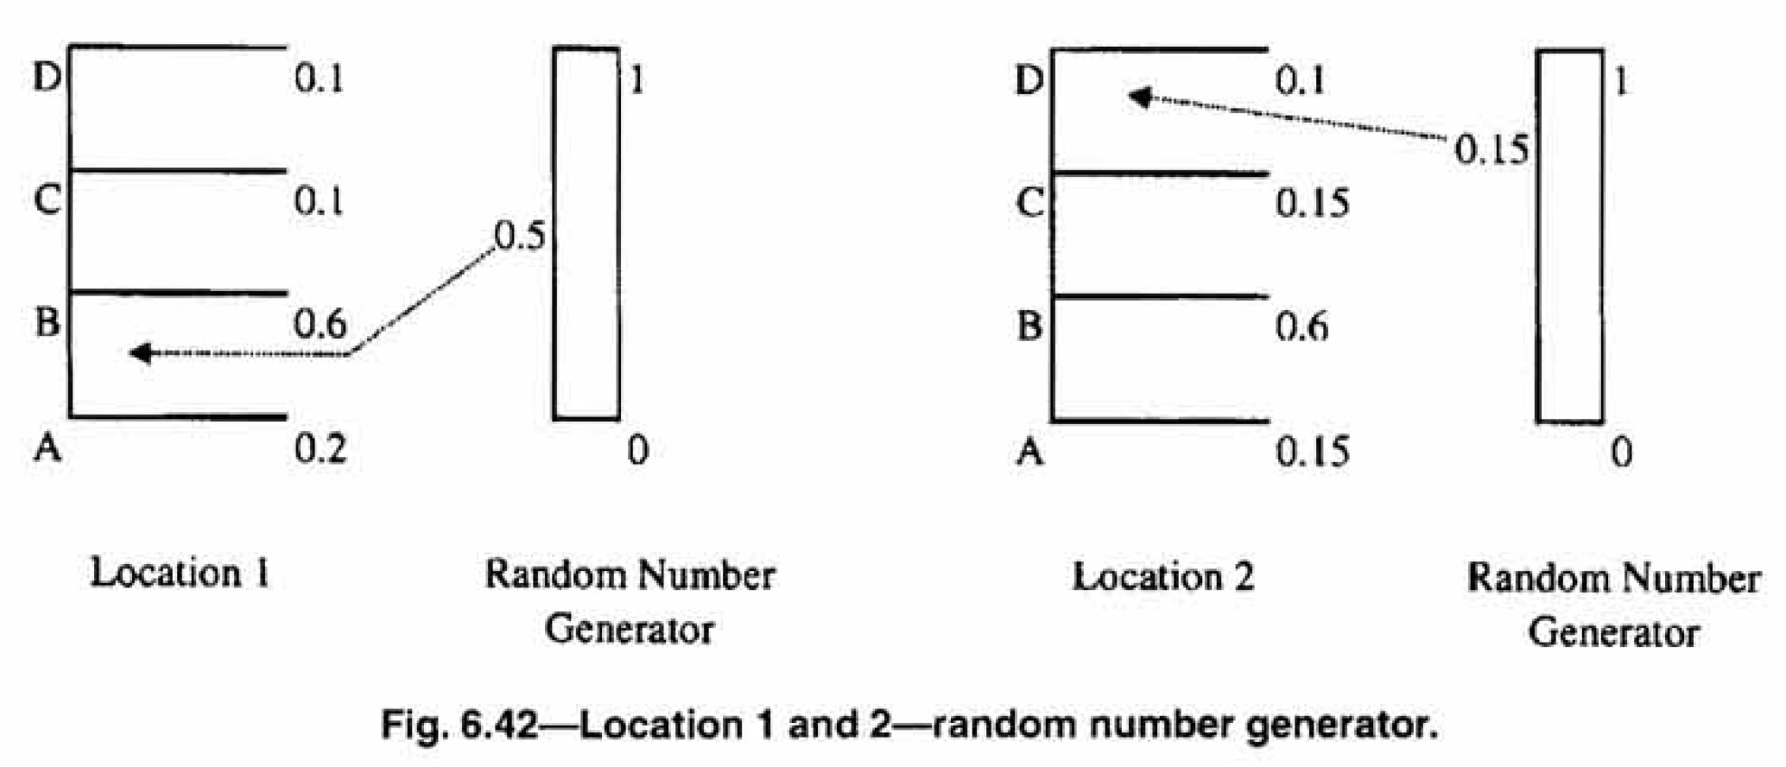

Options to overcome the above problem is to use **correlated random numbers** to simulate a value at each location. The simulated values at nearby locations exhibit similarities as implied by posterior distribution. E.g. if we use 0.5 at first location, we will use 0.52 to sample the location having similar estimated values. By using different sequences of correlated values that fall between 0 and 1, we can generate multiple realizations that don’t exhibit short scale variability.

1. One possibility is to use the **probability kriging**, based on the original sample data. Kriging is done over a larger grid than the desired domain, and by shifting the grid over the domain, we can progressively sample multiple value at each location.
2. Another alternative is the **Multi-Gaussian Fields** that have the desired correlation scale (spatial continuity) and transform them into value between 0 and 1 by calculating the CDF corresponding to each value.

## Simulated Annealing

### Background

### Simulation Algorithm

#### Initial Distribution

#### Objective Function

#### Spatial relationship

#### Cumulative Distribution Function

#### Correlation between variables

#### Well Test Permeability

#### Production Data

#### Interchange Mechanism

## Simulation Process

### Input Parameters

#### Simulated Annealing Simulation

|  |  |  |  |  |  |  |  |
| --- | --- | --- | --- | --- | --- | --- | --- |
| **Simulation Summary** | | 1. **Transformation** | 1. **Variogram Modelling** | 1. **Determine random path** | 1. **Value & Uncertainty Estimation in the transformed domain** | 1. **Back transformation** | |
| **Indicator Transform** | **Discrete** |  | Number of variograms are equal to the **number of thresholds** to be modelled. | It involves selection of a path, in which every unsampled location is visited. With the help of a random number generator, a sequence of random numbers corresponding to the total number of gridblocks is generated, and based on the order, a path is selected in which the unsampled locations are visited. | Uncertainty is quantified by the probability associated to each threshold. | ***Data Correction*** | ***Back Transformation*** |
| **Continuous** |  | Uncertainty is quantified by the probability associated to each threshold. | ***Data Correction*** | ***Back Transformation*** |
| **Gaussian Transform** | **Discrete** |  | Only **one variogram** to be modelled | Uncertainty is quantified by the associated calculated error variance for each of the points. | ***Generating realization*** | ***Transforming realization to original domain*** |
| **Continuous** |  | ***Generating realization*** | ***Transforming realization to original domain*** |
| **lity Transform** | **Discrete** |  | Only **one variogram** to be modelled | Uncertainty is quantified by the probability associated to each surrounding samples. | ***Generating Realization*** | ***Transforming realization to original domain*** |
| **Continuous** | . For a **continuous variable**, once the CDF is created, we use the CDF as the transform variable with value between 0 and 1. | ***Generating Realization*** | ***Transforming realization to original domain*** |